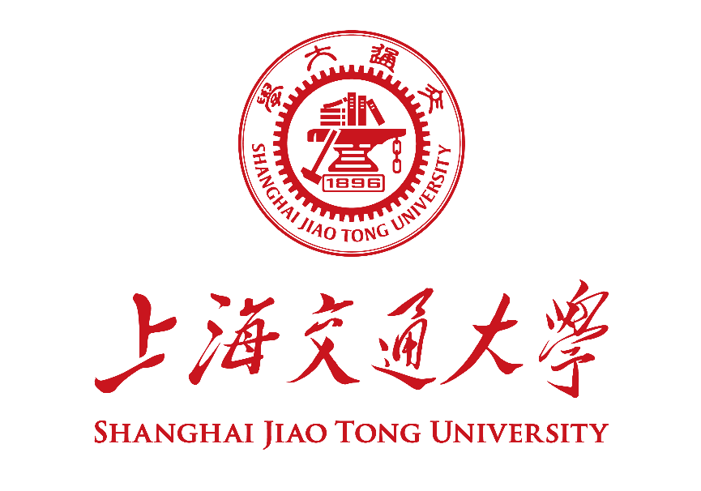

硕士研究生学位论文中期检查报告
Mid-term Examination Report for SJTU Master Student

学号 Student ID
姓名 Name
学生类别  Degree Program | 选择一项。
学习形式  Study Mode | 选择一项。
导师 Supervisor(s)
专业 Major
学院 School
考核日期 Date

- 中期检查报告 Mid-term Examination Report
论文题目
Thesis Title
研究课题来源  Source of Research Project | 请在合适选项前画√ Please select the proper options by “√”.  ☐ 国家自然科学基金课题 NSFC Research Grants  ☐ 国家重大科研专项 National Key Research Projects  ☐ 其它纵向科研课题 Other Governmental Research Grants  ☐ 企业横向课题 R&D Projects from Industry  ☐ 自拟课题 Self-proposed Project
论文开题日期
Thesis Proposal Date
- 报告正文 Report。请阐述开题报告以来学位论文研究工作的进展情况及所取得的阶段性成果，并简述下一阶段研究计划，不少于4000汉字。Please summarize your research progress and achievements since your thesis proposal as well as your plan for next step. No less than 3200 words if written in English.

- 成果清单 List of Achievements。请列出开题报告以来或上次年度进展报告以来新发表的学术论文、授权专利、国际会议论文、专著等成果清单。Please provide a list of academic publications (papers, patents, international academic conference talks/presentations, monographs, etc.) since your thesis proposal.

本人承诺：报告中的内容真实无误，若有不实，愿承担相应的责任和后果。 I hereby declare and confirm that the details provided in this Form are valid and accurate. If anything untruthful found, I will bear the corresponding liabilities and consequences.

学生签字/Signature of Student： 日期/Date： 2019-12-03
二、中期检查评审 Review of the Mid-term Examination Report (注：通过在线流程进行时，第二部分可删除；This section can be removed if the report is submitted through My SJTU.)
- 课程学习情况 Coursework （本栏由研究生填写，导师负责核对确认This table shall be filled by the graduate student, and verified by the supervisor.）
培养计划中是否尚有未通过课程？Is there any unpassed course remained in the training plan? | ○ 是Yes ○ 否No
培养方案要求总学分、GPA学分
Total credits and GPA credits required by the program
培养计划总学分、GPA学分
Total credits and GPA credits of the training plan
已修课程总学分、GPA学分
Total credit and GPA credits acquired hitherto
已修课程GPA
GPA of the finished courses

- 导师意见Comments of Supervisor
- 请确认课程学习情况信息的准确性 Please confirm if the information provided in the Coursework section is valid/accurate or not:
○ 准确无误Valid and accurate ○ 有不确切处Inaccurate
- 请综合评价研究生的科研进展、成果水平、治学态度等。Please comment on the progress, achievement, and altitude of the graduate student.

签名/Signature： 日期/Date： 2019-12-03
- 专家评审Committee Review
- 专家组成员 Review Committee Members
序号  Index | 姓名  Name | 工号  Work ID | 职 称  Title | 工 作 单 位  Affiliation | 本人签名  Signature
1
2
3
4
5
秘书

- 专家组意见Comments

- 专家评审结论 Conclusion
○ 通过 Pass ○ 不通过 Fail

专家组长签名/Signature： 日期/Date： 2019-12-03

- 院系审核意见School Review
○ 通过 Pass
○ 不通过 Fail，建议 Suggested to
○ 建议下学期重来 A second chance in next semester
○ 建议退学 Withdraw from the university

主管领导签字Signature 盖章Stamp 日期Date:
说明：本报告由院系研究生教务办负责存档，中期检查结论由研究生教务在研究生信息管理系统登录。
备注Remarks:

